COOK BOOK YOUR VIRTUAL KITCHEN ASSITANT

# **INTRODUCTION**

## **PROJECT TITTLE: COOK BOOK**

# **TEAM MEMBERS:**

|  |  |  |
| --- | --- | --- |
| **TEAM MEMBERS** | **E-MAIL ID** | **ROLE** |
| GAJASH SHRI T | **gajashsrirtvel@gmail.com** | Lead Developer |
| MONISHA M | **monishamoni4644@gmail.com** | UI/UX Developer |
| SRIVIDHYA S | **srividhyasrinivasan202005@gmail.com** | Frontend Developer |
| NAVEENA SHREE R | **rnaveenashee@gamil .com** | Frontend Developer |

# 2.PROJECT OVERVIEW

# **PURPOSE**

Cookbook is a revolutionary web application designed to change the way you discover,organize and crerate recipes.it caters to both novice and professional chefs,offering a u ser friendly interface,robust features,and a vast collection of inspiring recipes.

# **ARCHITECTURE**

The user experience starts with the cookbooks web application UI likely built with a framework like react or Vue.js for a smooth single page experience.This UI interacts with an API client specifically designed for cookbooks. This client handles communication with the backend,but with a twist; it leverages Rapid API, a platform providing access to various external APIs.

# **SETUP INSTRUCTION**

Sarah rummaged through the fridge, the fluorescent light casting an unappetizing glow on the wilting lettuce and forgotten container of yogurt. Dinnertime with her teenage son, Ethan, was fast approaching, and her usual creative spark was missing. "What are we even going to eat?" Ethan groaned from the doorway, his phone glued to his ear. Suddenly, a memory surfaced. Her friend, Maya, had been raving about a new recipe platform called CookBook. Intrigued by the promise of "elevating culinary endeavors" and "a realm ofdelicious possibilities," Sarah grabbed her laptop. "Hold that thought, Ethan," she declared, a flicker of hope igniting in her eyes. "We might just be about to embark on a delicious adventure."

# **FOLDER STRUCTURE**

* /src
* /component
* /About.jsx
* /CategoriesHome.jsx
* /Footer.jsx
* /Hero.jsx
* /Navbar.jsx
* /NewsLetter.jsx
* /images
* /pages
* /Category.jsx
* /Home.jsx
* /Recipie.jsx
* /styles
* /About.css
* /CategoriesHome.css
* /Categorypage.css
* /Footer.css
* /Hero.css
* /Home.css
* /Navbar.css
* /NewsLetter.css
* /Recipie.css

# **RUNNING THE APPLICATION**

* Provide comments to start the frontend server locally.

Frontend : npm start in the client directory

**COMPONENT DOCUMENTATION**

Components

1. **Recipes:** The main content of the cookbook, including ingredients, instructions, and cooking methods.

2. **Ingredients**: A list of ingredients required for each recipe, including measurements and preparation instructions.

3. **Instructions**: Step-by-step instructions for preparing and cooking each recipe.

4. **Cooking Methods**: Explanations of various cooking techniques, such as roasting, grilling, or sautéing.

**STATE MANAGEMENT**

1. **Local Storage:** Storing state locally on the user's device, such as using cookies or local storage.

2. **Session Storage**: Storing state temporarily for the duration of the user's session.

3. **Server-Side Storage:** Storing state on the server-side, such as using a database or API.

4. **Redux or Flux**: Using a state management library like Redux or Flux to manage state globally.

**STYLING**

1. **Color Scheme**: Warm and inviting colors (#F7D2C4, #2E4053, #FFC107)
2. **Typography**: Open-source font (Lato, Merriweather), 16px-48px font sizes
3. **Layout**: 12-column grid, consistent spacing (16px, 24px)
4. **Components**: Recipe cards, navigation, buttons, icons
5. **Screens:** Home, recipe, search, profile
6. **Responsive Design**: Mobile-first, flexbox, grid
7. **Accessibility:** WCAG 2.1 guidelines, clear typography and layout.

**USER INTERFACE** 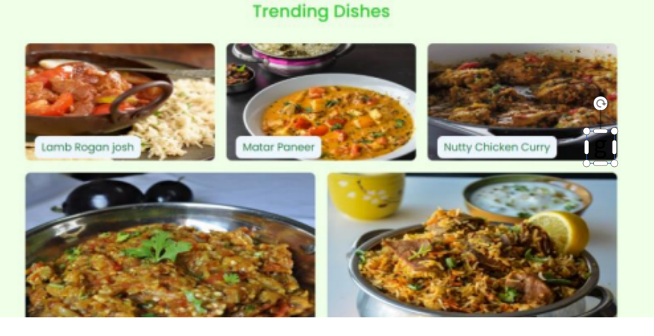

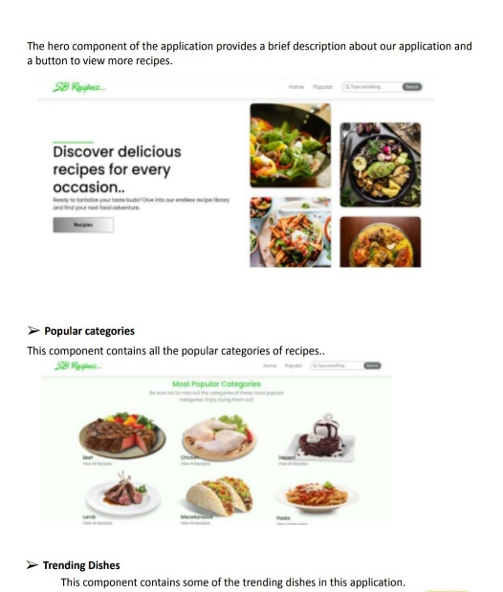

**TESTING**

1. **Unit Testing**: Test individual components, such as recipe rendering or search functionality.

2. **Integration Testing**: Test how components interact with each other, such as navigating from the home screen to a recipe.

3. **UI Testing**: Test the user interface, including layout, typography, and visual design.

**PROJECT DEMO LINK**

<https://drive.google.com/file/d/1QsqGkYxHYcHPTgOZtdYyKb-2wwsL-J9H/view?usp=sharing>

**KNOWN ISSUES**

**Recipe rendering errors**

1. Search functionality issues
2. Navigation problems
3. User profile issues

**UI/UX Issues**

1. Layout issues

2. Typography issues

3. Color scheme issues

**Data Issues**

1. Recipe data inaccuracies

2. User data issues

3. Data synchronization issues

**Security Issues**

1. User authentication issues

2. Data encryption issues

3. SQL injection vulnerabilities

**FUTURE ENCHANCEMENT**

Features

1. Meal planning

2. Recipe suggestions

3. Social sharing

4. Recipe editing